**Computer Organization and Architecture (EET2211)**

**LAB V: Addition of two BCD numbers**

**Siksha ‘O’ Anusandhan Deemed to be University, Bhubaneswar**

|  |  |  |  |
| --- | --- | --- | --- |
| **Branch:** Computer Science and Engineering **Section:** ‘D’ | | | |
| **S. No.** | **Name** | **Registration No.** | **Signature** |
| 52 | Saswat Mohanty | 1941012407 | **D:\Pics and Sign\sign.jpg** |

**Marks: ______/10**

**Remarks:**

**Teacher’s Signature**

**I. OBJECTIVE:**

1. Write a program to find the sum of two BCD numbers.

**II. PRE-LAB**

**For Obj. 1:**

1. **Find the sum of two BCD numbers.**

[1000h] = 2222h

[1002h] = 1111h

Output: 3333h

1. **Write the assembly code.**

|  |
| --- |
| **org 100h**  **mov ax,0000h**  **mov ds,ax**  **mov al,[3000h]**  **mov bl,[3002h]**  **add al,bl**  **daa**  **mov [3004h],al**  **mov al,[3001h]**  **mov bl,[3003h]**  **adc al,bl**  **daa**  **mov [3005h],al**  **mov al,00**  **adc al,al**  **mov [3006h],al**  **hlt**  **ret** |

**III. LAB:**

**Assembly Program:**

**For Obj. 1:**

|  |
| --- |
| **; SASWAT MOHANTY**  **; 1941012407**  **; Write a program to find the sum of two BCD numbers.**  **org 100h**  **mov ax,0000h**  **mov ds,ax**  **mov al,[3000h] ; Value stored at 3000 = 3333**  **mov bl,[3002h] ; Value stored at 3002 = 1111**  **add al,bl**  **daa ; BCD code for 3333 : 0011 0011 0011 0011**  **mov [3004h],al ; BCD code for 1111 : 0001 0001 0001 0001**  **mov al,[3001h] ; ------------------------------------------**  **mov bl,[3003h] ; Addition : 0100 0100 0100 0100**  **adc al,bl ; BCD Value : 4 4 4 4**  **daa**  **mov [3005h],al ; So final BCD addition value is 4444**  **mov al,00**  **adc al,al**  **mov [3006h],al**  **hlt**    **ret** |

**Observations (with screen shots):**

**For Obj. 1:**

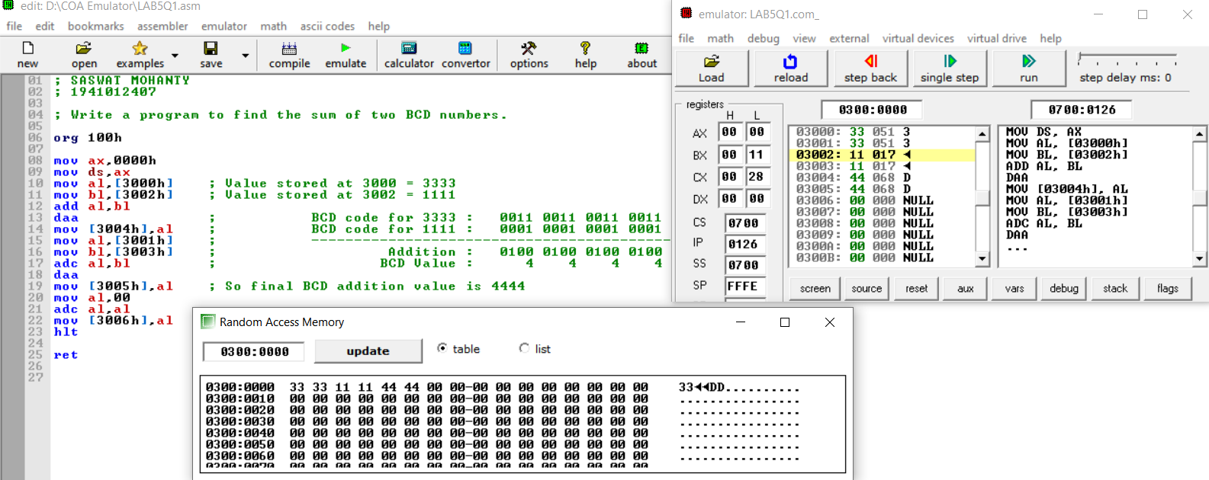

**Conclusion:**

It can be concluded that the addition of two BCD numbers when dry run and executed in system found to be same. Thus, the program to find the sum of two BCD numbers was executed.

**IV. POST LAB:**

1. **What is the maximum memory size that can be addressed by 8086?**

In 8086 microprocessor the total memory addressing capability is 1MB. For representing 1MB there are minimum 4 hex digits are required i.e., 20 bits. 8086 microprocessors have fourteen 16 bit registers (i.e. there are no registers for representing 20 bit address). So, the total memory can be divided into 16 separate logical segments and each segment capacity is 64KB (i.e., 16 * 64 KB = 1MB).

1. **Which of the following is not a data copy/transfer instruction? Explain.**
2. **MOV b) PUSH**
3. **DAS d) POP**

DAS is the answer because, it’s used to adjust decimal after subtraction.

1. **Write Down the Comparisons between the 8086 and 8088?**

|  |  |  |
| --- | --- | --- |
|  | **8086** | **8088** |
| Clock Speeds | 5MHz, 8MHz, 10MHz | 5MHz, 8MHz |
| Bus Width | 16 bits | 8 bits |
| Number of Transistors | 29,000 | 29,000 |
| Feature size | 3 | 6 |
| Addressable Memory | 1MB | 1MB |